Ortak Anot
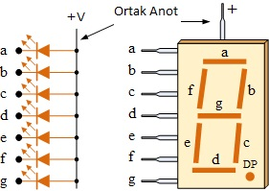

Ortak Katot
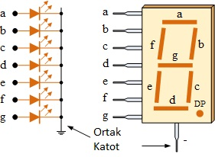
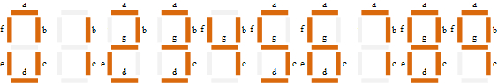
Ortak Anot | P2.7 | P2.6 | P2.5 | P2.4 | P2.3 | P2.2 | P2.1 | P2.0
Hangi Şekil | a | b | c | d | e | f | g | h(DP)
4(99H) | 1 | 0 | 0 | 1 | 1 | 0 | 0 | 1
5(49H) | 0 | 1 | 0 | 0 | 1 | 0 | 0 | 1
7(1Fh) | 0 | 0 | 0 | 1 | 1 | 1 | 1 | 1

Ortak Katot | P2.7 | P2.6 | P2.5 | P2.4 | P2.3 | P2.2 | P2.1 | P2.0
Hangi Şekil | a | b | c | d | e | f | g | h(DP)
4(66h) | 0 | 1 | 1 | 0 | 0 | 1 | 1 | 0
5(0B6H) | 1 | 0 | 1 | 1 | 0 | 1 | 1 | 0
8(0FEH)



4x4 keypad
 |  | C1 | C2 | C3 | C4 |  | 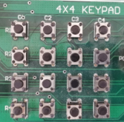
 |  | 0.3 | 0.2 | 0.1 | 0.0
R1 | 0.7
R2 | 0.6
R3 | 0.5
R4 | 0.4

